Santa Lucia Maritime Crewing Agency

17 Bogoroditska, office 322, Kherson, Ukraine
tel: +380-956-744-192 ;+380-664-436-321 e-mail: santalucia.maritimecrewagency@gmail.com

PHOTO

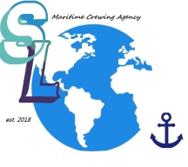

APPLICATION FORM

GENERAL INFORMATION
Position – |  |  | Available from |  |  |  |  | Min salary -
Surname - |  | First name - |  |  | Middle name -
Date and Country of birth – |  |  |  |  |  |  | Nationality -
Home address -
Phone - |  | Mob. - + |  |  | E-Mail –
English level | Excellent |  |  | Good |  | Satisfactory |  |  | Poor
Marital status – married/single |  |  |  | Children (under 18 yrs.)
Next of kin (full name/relation) –
Education -

PERSONAL DETAILS
Documents | Number | Date/Place of issue | Date of expiry
International Passport (OVIR)
Seaman’s Passport
USA Visa
Shengen Visa
Other (if any)
Medical Exam
Drug & Alcohol Test
Yellow Fever

NATIONAL DOCUMENTS AND CERTIFICATES
Certificate |  |  | Number |  | Date of issue |  |  |  | Authority |  | Place of issue
Competency | Grade
Endorsement of Competency
GMDSS Operator
Endorsement of GMDSS
ECDIS (Generic)
Basic Safety Training
Proficiency in survival craft’s
Advanced fire fighting
Medical first aid
Radar Observation & Plotting
Automatic Radar Plotting Aids
Bridge Team Management
Bridge Resources Management
Security awareness training
Hazardous Cargo (HAZMAT)
Ship’s medical care
Ship’s Security Officer
Security Training for Seafarers with Designated Security Duties
OTHER DOCUMENTS AND CERTIFICATES
Certificate |  | Number |  |  |  |  | Date of issue |  | Authority |  | Place of issue
FLAG STATE DOCUMENTS
Document |  |  |  |  |  | Country |  | Number |  | Issued |  | Expired

RECORDS OF SEA SERVICE (LAST 5 YEARS)
Ship’s name | Y. O. B. | Type | DWT | GRT/NRT | Country (Flag) | Owner/  Manager | Position | Period  from (d/m/y)  till (d/m/y)

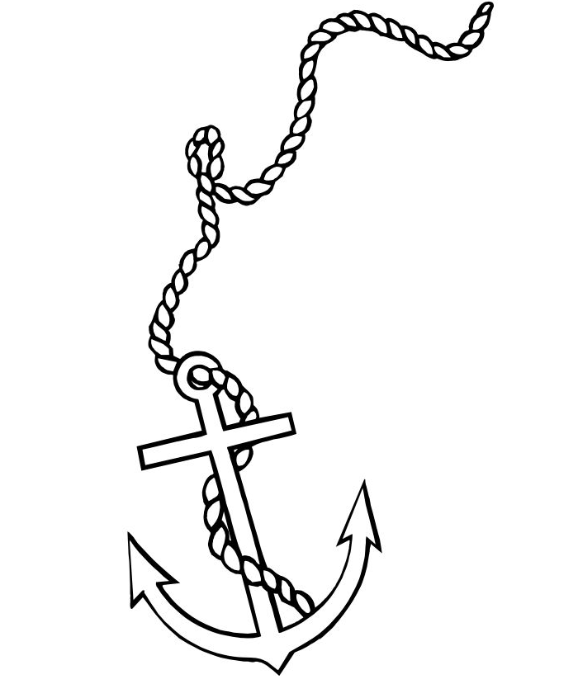
NOTES (for office use only)
Дозвіл
на збір та обробку персональних даних

Заповнюючи та надсилаючи цю анкету, згідно з Законом України «Про захист персональних даних» від 01.06.2010 року № 2297-УІ, даю згоду ТОВ «Санта Лючія » Морська Крюїнгова Компанія збору та обробки моїх особистих даних, в тому числі даних, що стосуються здоров'я , в картотеках та / або в електронному вигляді, з метою працевлаштування на роботу за кордон (на суди іноземних судновласників), для забезпечення реалізації господарсько-правових та громадянсько-правових відносин, трудових відносин, відносин у сфері управління людськими ресурсами та ведення діловодства, підготовки відповідно до законодавства статистичної та іншої інформації.
Dear Seafarers , LLC “SANTA LUCIA” is not an employer. We're considering Your application as request for cooperation for employment. Filling of application can’t guarantee the employment, it's needed for consideration You as a candidate from our agency.Every seafarer is a face of his crewing agency.

Initials ____________________ ___________
_{(підпис)}

Test’s
CES (If available) –

Marlins (If available)-

Videotel (If available)-

Internal interview -

